Sorting & Selection Exercises
Questions by: Ibrahim Albluwi and Sufyan Almajali
Solutions by: Ibrahim Albluwi, Sufyan Almajali, DANA AL-TAHER, Abdulrahman Abudabaseh

Exercise 1 (Tracing & Analysis)
A. For each of the following pairs of sub-arrays, count the number of data moves and data compares performed by the MERGE function in Merge Sort. Assume that each subarray is of size n/2.
Express your answer using tilde notation.
- [n n n n n n n n … n] [1 2 3 4 5 6 7 8 … n/2]
- [1 2 3 4 5 6 7 8 … n/2] [1 2 3 4 5 6 7 8 … n/2]

B. For each of the following arrays, count the number of swaps and data compares performed by the PARTITION function in Quicksort. Assume that the pivot is the first element and that the size of the array is n.
Express your answer using tilde notation.
- [1 2 3 4 5 6 7 8 9 10 11 12 … n]
- [1 2 2 2 2 2 … 2 0 0 0 0 0 … 0] // number of 2’s = number of 0’s
- [1 2 1 2 1 2 … 1 2]

C. Consider the array a[], which was partitioned only once during the execution of Quicksort. The array contents look as follows after the PARTITION function finished executing:
a = [1, 5, 7, 2, 9, 12, 11, 10]. Which elements could have possibly been the pivot?

Exercise 2 (Analysis)
A. Given an array of size n that is a power of 2:
- How many times will the MERGE function be called in Merge Sort?
- How many times will the PARTITION function be called in Quick Sort?
Provide your answer for the best case and the worst case and express your answer in tilde notation.
B. Consider a variant of Quicksort that uses Quick-Select to find the median in each partitioning step and uses it as the pivot. Analyze the number of data compares performed by Quicksort in the best case and in the worst case.
C. Consider an algorithm named Randomized-Sort that uses the Quick-Select algorithm to sort n elements, where Quick-Select is called to find the smallest element in the array, then is called again to find the 2nd smallest, then the 3rd, etc. Whenever the k^{th} smallest element is found, it is placed in its correct position in a new array. Randomized-Sort at the end copies back all of the elements that are in the sorted array into the original array.
Analyze the best case and worst case running time of this algorithm

Exercise 3 (Design)
A. Consider the following Quicksort function:
1  2  3  4  5  6  7 | QUICKSORT(a[], first, last)  if (first >= last)  return  p = PARTITION(a, first, last)  QUICK-SORT (a, first, p - 1)  QUICK-SORT (a, p + 1, last)

Modify the Quicksort algorithm, such that it guarantees that the PARTITION function will always produce two non-empty partitions if the partitioned range has 8 elements or more.
Note the following:
- You are not allowed to change lines 5, 6 or 7. Your modifications must all happen before these lines.
- Assume that the PARTITION function uses the first element in the range as the pivot.
- Assume that the array has no duplicate elements.

B. Design a new divide and conquer algorithm named RangeQuickSort. Given an array a[] and a range of values [A … B], the algorithm sorts only the values of the array that fall within the given range. Assume that the values A and B exist in the array.
Example. a[] = {14, 98, 16, 12, 15,5, 88, 2, 20, 33}
Calling RangeQuickSort(a, 0, 9, 14, 20) should return array with the values in
the range 14 to 20 sorted:
a[] = {5, 12, 2, 14, 15, 16, 20, 88, 33, 98}
Notes.
- The values to the left of the range and the values to the right of the range could be of any order and do not have to be sorted.
- Your algorithm must be more efficient than sorting the whole array.

Exercise 4 (Sorting & Recurrence Equations)
A. Assume that the MERGE function in Merge Sort was modified such that it returns (without doing anything) if a[mid] <= a[mid+1].
Fill out the following table regarding the number of data compares done by Merge Sort (the whole algorithm, not only the MERGE function).

 | Best Case | Worst Case
Provide an example
Array of size 8
Describe the running
time using a recurrence equation
Running Time in Tilde (~) notation for an array of size n

B. Consider the following code for a modified version of the Quick Sort algorithm:
1  2  3  4  5  6  7 | QUICKSORT(a[], first, last)  if (first >= last)  return  p = PARTITION(a, first, last)  SORT-A (a, first, p - 1)  SORT-B (a, p + 1, last)

Fill out the following table below assuming SORT-A(...) and SORT-B(...) are replaced with the corresponding options.
- Assume that PARTITION picks the first element in the sorted range as the pivot.
- Remember that the running time of insertion sort is Θ(n²) in the worst case and Θ(n) in the best case, while selection sort runs in Θ(n²).
Type of Sorted Data | SORT-A | SORT-B | Recurrence Equation
Sorted  (ascending) | Insertion Sort | Quick Sort
Random  (pivot is the median) | Merge Sort | Quick Sort
Random  (pivot is the median) | Selection Sort | Quick Sort
Sorted  (ascending) | Quick Sort | Insertion Sort

A screenshot from the midterm of Fall 2023
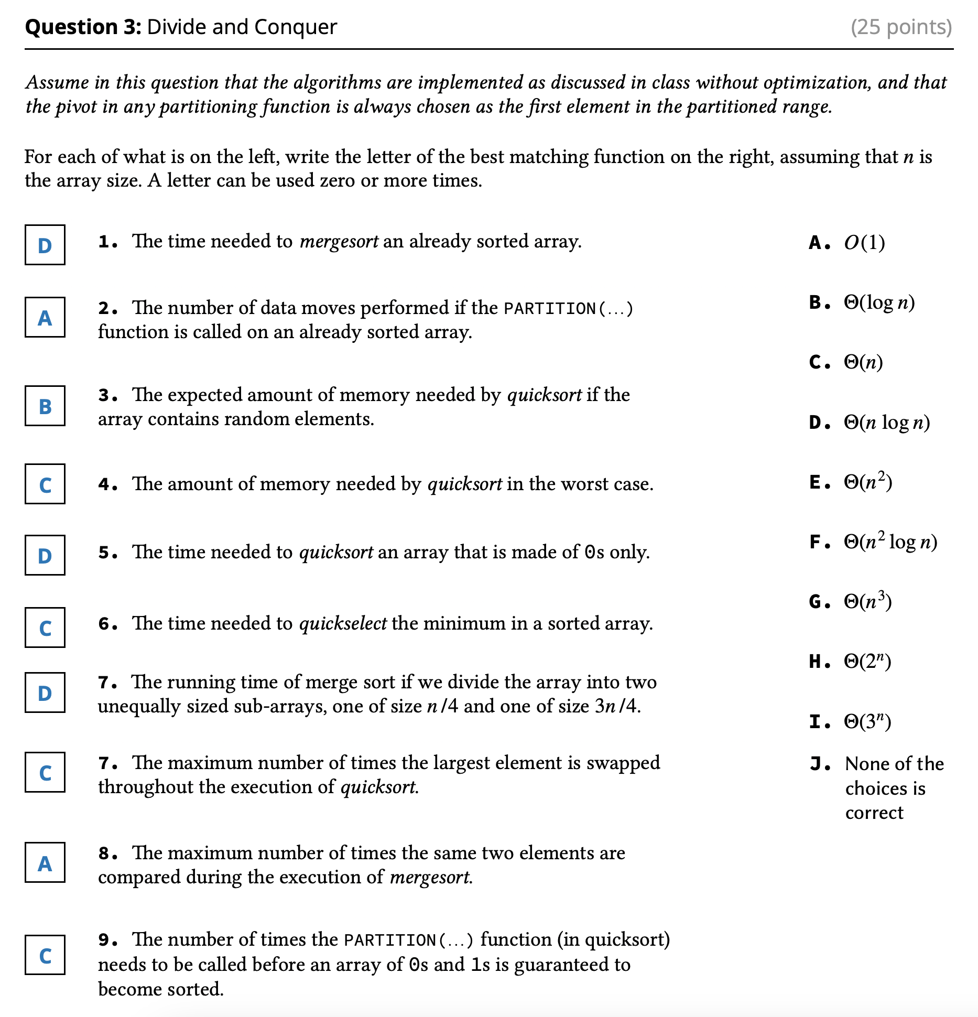

A screenshot from the midterm of Spring 2024
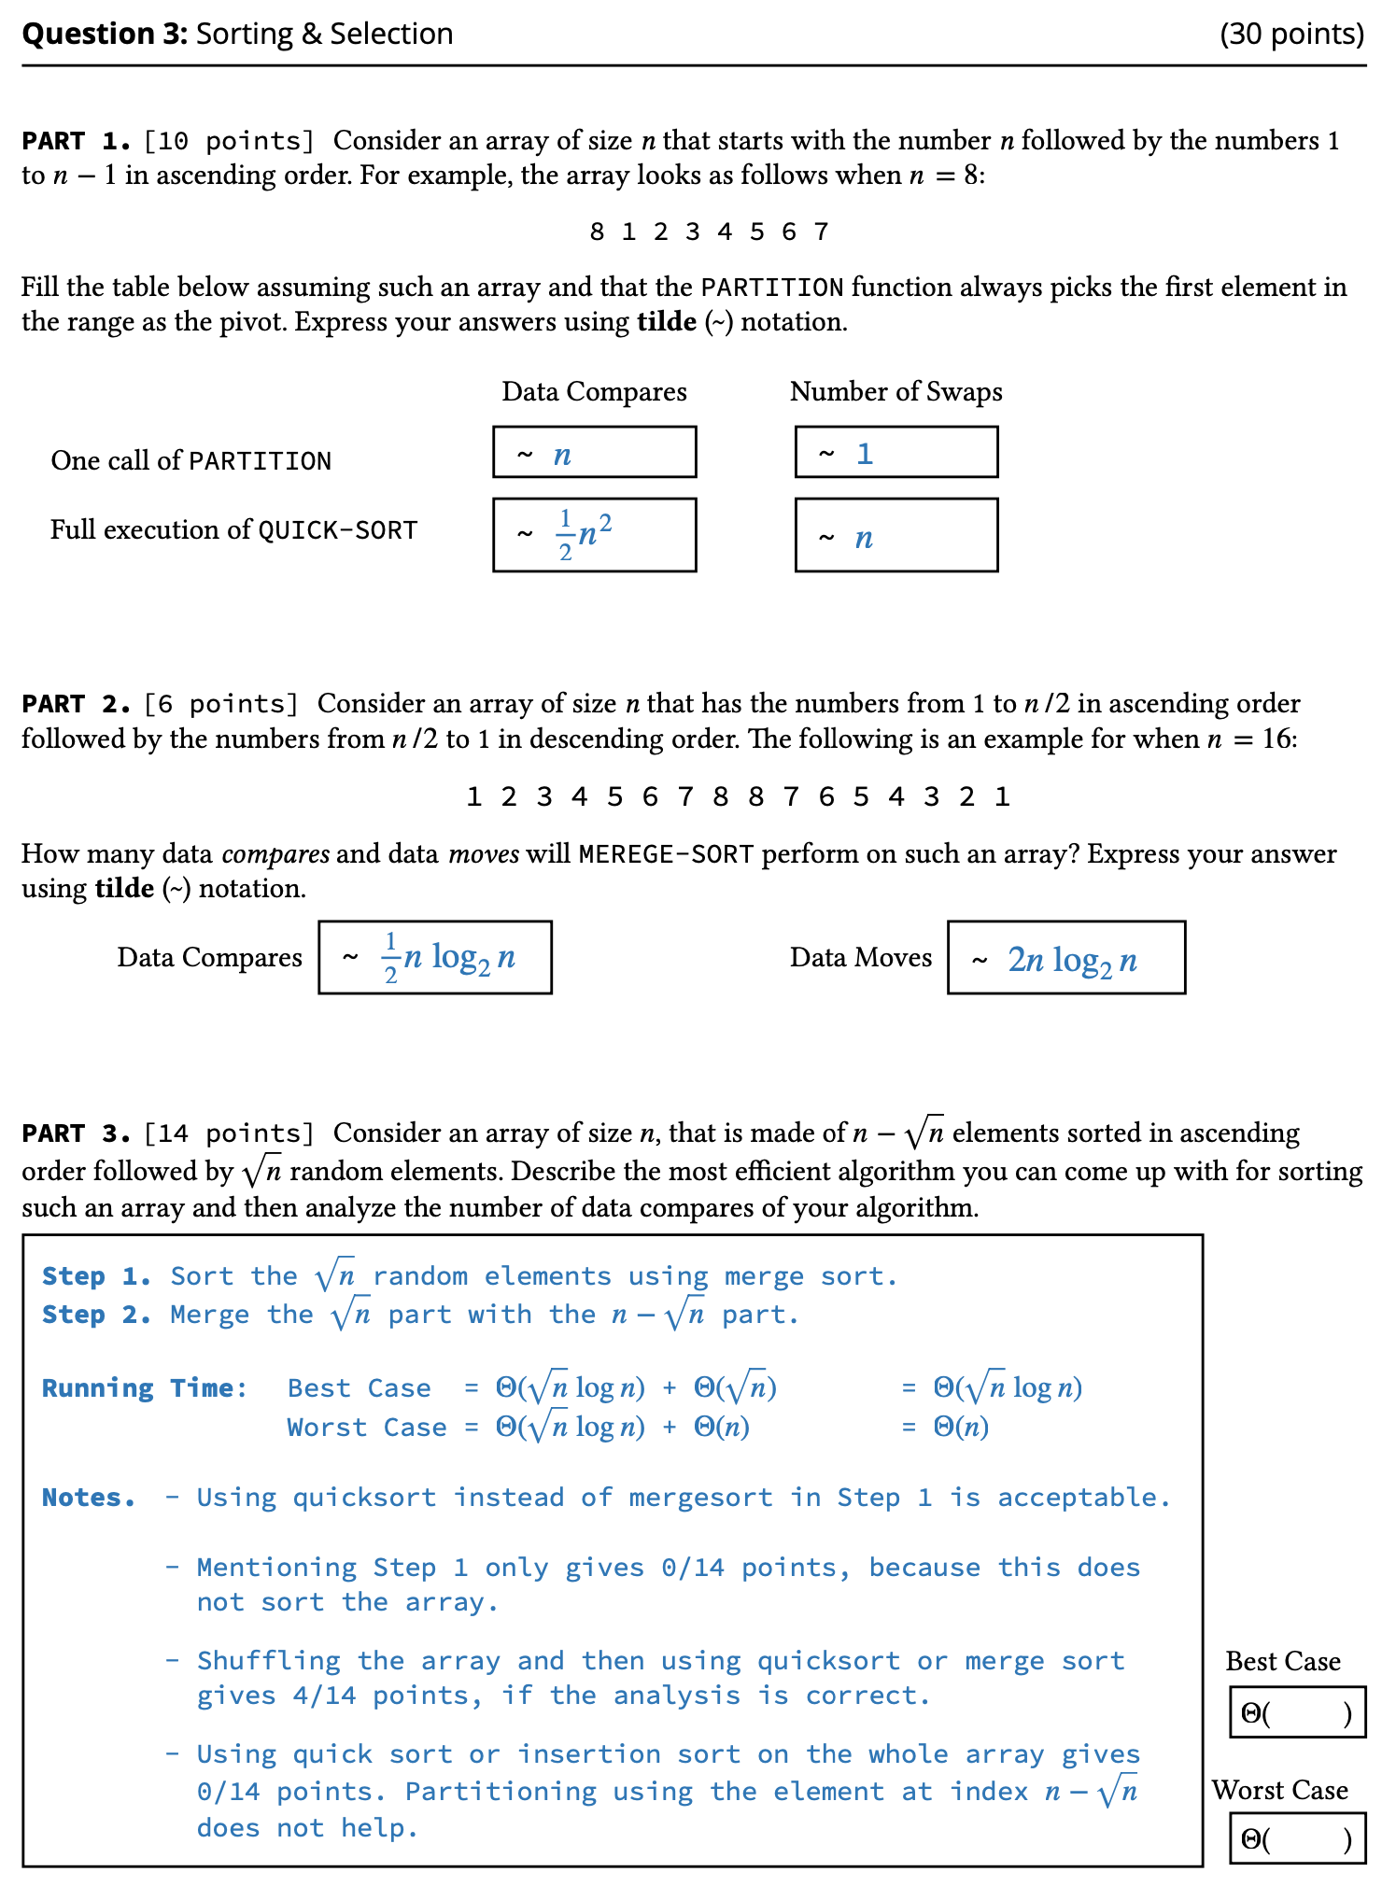

Solutions

1.A_

Arrays | Data Compares | Data Moves
- [n n n n n n n n … n] [1 2 3 4 5 6 7 8 … n/2] | ½ n | 2n
- [1 2 3 4 5 6 7 8 … n/2] [1 2 3 4 5 6 7 8 … n/2] | n-1 | 2n

1.B_

Arrays | Data Compares | Swaps
- [1 2 3 4 5 6 7 8 9 10 11 12 … n] | ~n | 1
- [1 2 2 2 2 2 … 2 0 0 0 0 0 … 0]  // number of 2’s = number of 0’s | ~n | ~n/2
- [1 2 1 2 1 2 … 1 2] | ~n | ~n/4

1.C_ 1 and 9
2.A_

 | Best Case | Worst Case
1 | ~n, exactly n-1 | ~n, exactly n-1
2 | ~n, exactly n-1 | ~n, exactly n-1

2.B_ Best case = 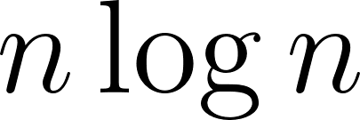 and worst case = 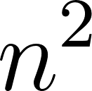
2.C_ Best case =  and worst case = 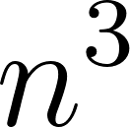

3.A_ The idea is to force the partition function to pick an element (as the pivot) that is not the maximum and not the minimum (since these are the cases that lead to an empty partition).
The following is one way that avoids picking the max or min as the pivot.

1  2  3  4  5  6  7  8  9  10  11  12  13  14  15  16  17 | QUICKSORT(a[], first, last)  if (first >= last):  return  if (last - first > 8):  x = a[first], y = a[first + 1], z = a[first + 2]  if (NOT(y < x AND y < z) AND NOT(y > x AND y > z))  // y is not min and not max  SWAP(a[first], a[first + 1])  else if (NOT(z < x AND z < y) AND NOT(z > x AND z > y))  // z is not min and not max  SWAP(a[first], a[first + 2])  // otherwise a[first] is not the min and not the max  p = PARTITION(a, first, last)  QUICK-SORT (a, first, p - 1)  QUICK-SORT (a, p + 1, last)

3.B_

1  2  3  4  5  6  7  8  9  10  11  12 | ​​RangeQuickSort(data[], first, last, A, B):  if (last <= first)  return;  p = Partition(data, first, last)  if (data[p] <= A):  RangeQuickSort(data, p + 1, last, A, B)  else if (data[p] >= B):  RangeQuickSort(data, first, p - 1, A, B)  else:  RangeQuickSort(data, first, p - 1, A, B)  RangeQuickSort(data, p + 1, last, A, B)

4.A_

 | Best Case | Worst Case
Provide an example  Array of size 8 | [1 2 3 4 5 6 7 8] | [1 2 1 4 1 3 1 5]
Describe the running  time using a recurrence equation | T(n) = 2T(n/2) + 1 | T(n) = 2T(n/2) + n
Running Time in Tilde (~) notation for an array of size n | ~n | ~nlog₂(n)

4.B_

Type of Sorted Data | SORT-A | SORT-B | Recurrence Equation
Sorted  (ascending) | Insertion Sort | Quick Sort | T(n) = T(n-1) + O(n)
Random  (pivot is the median) | Merge Sort | Quick Sort | T(n) = T(n/2) + O(nlogn)
Random  (pivot is the median) | Selection Sort | Quick Sort | T(n) = T(n/2) + O(n²)
Sorted  (ascending) | Quick Sort | Insertion Sort | T(n) = O(n)

